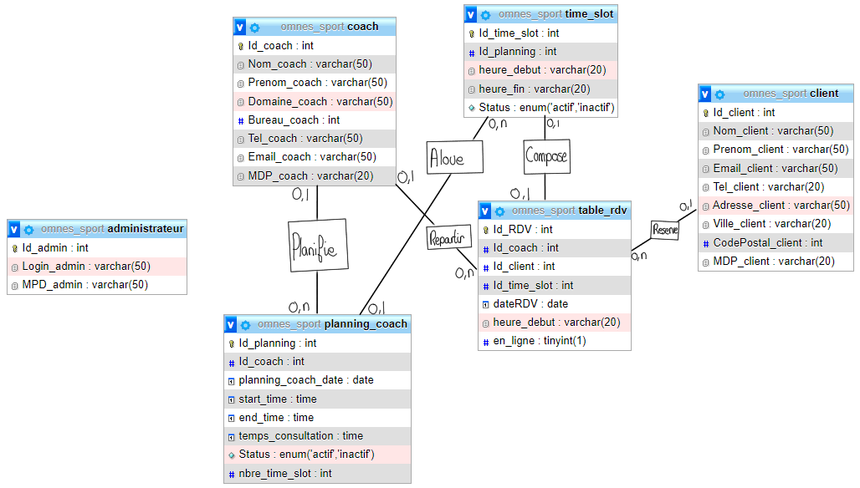

**MODÈLE RELATIONNEL :**

**Administrateur**(Id_admin, Login_admin, MPD_admin)

**Planning_coach**(Id_planning, #Id_coach, planning_coach_date, start_time, end_time, temps_consultation, Status, nbre_time_slot) **Coach**(Id_Coach, Nom_coach, Prenom_coach, Domaine_coach, Bureau_coach, Tel_coach, Email_coach, Email_coach, MDP_coach) **Time_slot**(Id_time_slot, #Id_planning, heure_depart, heure_fin, Status)

**Table_red**(Id_RDV, #Id_coach, #Id_client, #Id_time_slot, dateRDV, heure_depart, en_ligne)

**Client**(Id_client, Nom_client, Prenom_client, Email_client, Tel_client, Adresse_client, Ville_client, CodePostal_client, MDP_client)